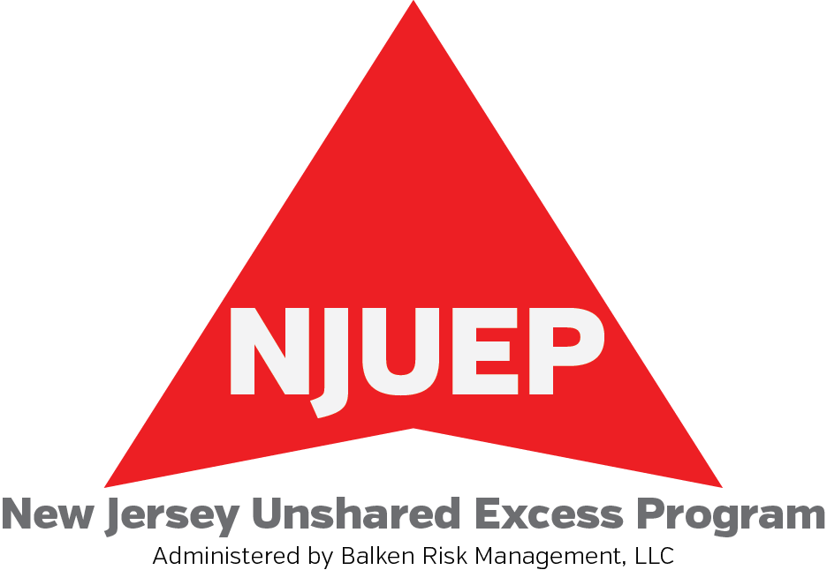 2014-2015 Application for Quotation

District Information

District Name: _ ________________________________________________________

Address: _______________________________ County: ___________________

Agency Name: ______________________ Address:__________________________

Contact Name/Email:__________________ Phone:____________________________

Quote Due Date: ___________________

Current Coverage Information

Current Underlying Carrier | Underlying Limits  (minimum 10M) | Coverage Expiration
School Bd Legal/EPL-
Auto Liability-
General Liability-
Umbrella-

Number of Students:

Elementary (K-8) ___________ High School __________ Special Ed ___________

ADA (Average Daily Attendance) ________________________

Current Auto Schedule
Auto Type | How Many?
PPT’s
Vans
Small Buses
Large Buses
Light Trucks
Medium Trucks
Trailers
Tractors
Other

Signature of Applicant: _______________________________ Date: ______________

*Applications must include 3-5 years of loss runs for GL/AL/UMB/SBLL/EPL

EMAIL OR FAX APPLICATIONS TO:

Balken Risk Management, LLC
777 Terrace Avenue Suite 309/Hasbrouck Heights, NJ 07604
Email: maria.makos@balkenrisk.com Fax: 201-584-0424

